Language, Literacy and Communication  In literacy we will be concentrating on:  - Reciprocal Reading Skills  - Recap different types of punctuation (VCOP)  - The Question Matrix  - Reading the class novel Coal Dust and Dreams  - Comprehension activities  - Hot seating  - Polonius the Pony  - The Big Pit recount  - Reading a range of sources to gather information about a Miner’s Day  - Poetry – Poems written by Welsh miner’s  - Diary writing – A day in the life of a miner  - Newspaper article writing - The disaster at Senghenydd and Aberfan  Welsh  Our Helpwr Heddiws will take the floor with introducing ‘Phrase of the Week’ and encouraging children to use the phrase (and previous phrases)  We will bel incorporating more Welsh language into our routines, as well as continuing to use lots of incidental Welsh in the classroom  There will be a focus on oracy through games and songs  Modern Foreign Language: German  We will be learning some simple German phrases which we can use in everyday life such as Guten Tag. | Year 5  ‘Pits and Ponies’  Autumn Term  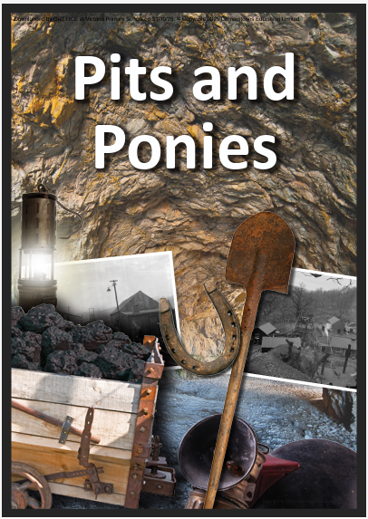 | Mathematics and Numeracy  In Numeracy the focus will be on extending the understanding of:  Place Value  - Place value, compare and order numbers up to 1 million.  - Rounding numbers to the nearest 10, 100 and 100  Number:  - Add and subtract two 4-digit numbers  - Round, estimate and approximate  - Multi-step addition and subtraction problems  - Add and subtract decimal numbers.  - Apply column addition and subtraction to word problems  - Financial literacy – calculating money  - Square numbers, prime numbers and cube numbers  - Multiply and divide by 10, 100 and up to 1000 using grid method and bus stop method  - Factors  Shape, Space and Measure:  - Understanding of the properties of 2D Shapes and 3D Shapes  - Types of triangles  - Calculate area of regular and irregular shapes.
Health & Well-being  Please ensure that children wear a suitable P.E kit on the following days:  Outdoor – Tuesday  Indoor - Friday  Indoor:  Dance – Coal mining dance  Gymnastics – the children will recap on, refine previous gymnastics movements, and have the opportunity to explore new movements too. They will link movements together into a sequence and perform (where appropriate) to their peers.  Outdoor:  OAA – Outdoor Adventurous Activities  Invasion games – the children will practise a range of games skills from different sports  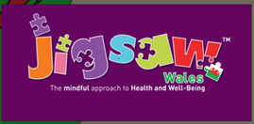  We will be using a resource called Jigsaw to support our teaching of Personal, Social and Health education. The resource has an excellent track record in promoting wellbeing among pupils as well as helping them to deal with situations that they encounter in school and at home. | Magic Moments  - Take One Picture Theme Week  - The Big Pit Virtual Workshop  - Big Pit  - Wales Millenium Centre Trip  - Show Racism the Red Card  - Harvest Festival  - Children in Need  - Anti-bullying Week  - Bigfoot Performance  - Winter Fayre  - Christmas Production at Stanwell | Cynefin  “Cynefin” is a Welsh term defined by Curriculum for Wales as 'the place where we feel we belong, where the people and landscape around us are familiar, and the sights and sounds are reassuringly recognisable.’  - Life in Wales as a miner  - The effect of the coal industry on the landscape and people
Children’s Independent Ideas
- Learn about children working in mines – what jobs did they do?
- Explore mining inventions like lamps, cages, and carts.
- Discover what a pit pony was! Why were ponies used underground?
- Interview grandparents or local people who remember mining.
- Visit a mining museum (like Big Pit or a local heritage site).
- Make a class timeline showing how mining changed over time
Humanities  How did it feel to work in the coal mines of Wales? How has the coal mining industry changed over the years and does it have a future? Explore these questions and more in this special project about the coal industry and its impact on the towns and valleys of Wales  - The history of coal mining  strikes and their effects on the miners, their families and communities.  - The legacy and future of coal mining.  - The role of the Pit Pony.  - The impact of the miner strikes  - Locating mines in Wales  - Inquiry question – Was coal mining a disaster for Wales?  - Tiger Bay coal export  RVE  We will be exploring the 1904 Welsh Religious Revival.  - Paul Robeson  The children will also explore children's rights through weekly assemblies.  We will continue to read a range of ‘No Outsiders’ books and have discussions about diversity, celebrating our differences and everything that makes us unique. | Expressive Arts  Children will learn about charcoal, and it’s use in creating portraits. They will learn techniques of shading and blending, combining these skills to create a portrait of a miner.  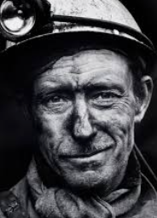  . | Science & Technology  - Formation of coal  - Renewable and non-renewable energy  - Children in Need profit  - Coal mines databases  - Algorithms and scratch coding  E-safety  The children will revisit e-safety and learn about factors to ensure they make safe and sensible choices online.
Growth Mindset
This year we will be exploring and learning all about Growth Mindset and the impact it can have on our brains. We will explore how Growth Mindset provides us with the tools to tackle challenges in our learning. Pupils will learn how to become more resilient in their learning and how they can develop throughout all lessons, both in and out of the classroom.

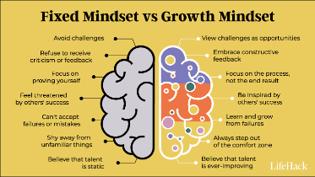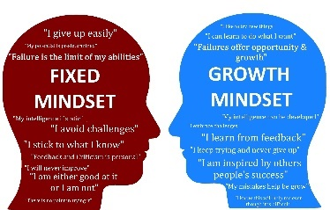

How can I support my child’s learning in this topic?

Homework – Please find work on Google Classroom. There is a specific classroom for homework.

Literacy:
READING - We recommend that children read every day, when possible, this should be to an adult or sibling but most importantly, we want the children to read regularly and enjoy it. Children can read the books sent home from school alongside books of their own free choice and interest. Children can write in their log themselves or a comment can be written by the person who has listened to them.

SPELLING - The spelling lists are shared on Google Classroom at the beginning of each half term. Spelling tests are every Monday morning. Children can practice these in whatever way they wish such as writing them on flashcards, playing a memory game or applying the words in sentences. Please encourage your child to look up the meaning of the word using a dictionary.

LEXIA – If your child uses Lexia, please encourage them to access this at home as much as possible.

Numeracy:
Maths homework to reinforce skills taught in school will be posted into Google Classroom on a Monday, all homework must be handed in by the following Monday. There is no need to print the homework as answers can be typed onto a Google Doc or written in a notebook. Children can then photograph their work, upload and submit or they can bring the homework into school. Encourage your child to practice and learn by heart their times tables and their related division facts. Play number games that test your child’s times table knowledge to make the experience more enjoyable, many of the children enjoy electronic games such as hit the button but singing songs or chanting them also works well.

