Language, Literacy and Communication  In literacy we will be concentrating on:  - News Reports  - Story Writing  - Tongue Twister and Acrostic Poetry  Oracy:  - Asking a variety of questions; who, what, why, where?  - Giving opinions based on research.  - Presenting work and ideas to others.  Reading:  - Using contents page and glossary in a range of texts.  - Identify and use text features e.g. titles and headings to locate information.  - Read and watch a variety of news stimulus.  Writing:  Non-Fiction Writing:  - Newspaper Articles – including who, what, where why?  - Letter Writing – Linked to conservation and awareness of environmental issues.  - Story Writing  Consolidation of skills:  - Correct letter formation.  - Use of full stops and capital letters.  - Use of finger spaces when writing.  - WOW words.  - Recognition and application of phonemes.  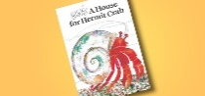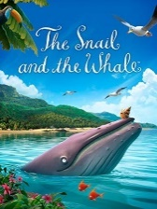  International Languages  Welsh Language Development  In Welsh we will be looking at:  Feelings – Teimlo and Bwyd-Food  - Learning vocabulary and sentence patterns to identify types of food and feelings.  - Learning different sentence structures to describe how we are feeling.  - Ask and answer questions in Welsh about food.  - Read books and understand stories.  - Begin to write about foods we like and don’t like.  - Incidental Welsh e.g. daily routine  We will be practising simple sentence patterns through discussion as well as simple written activities exploring our themes.  We will also be using lots of incidental Welsh in the classroom.  Eisteddfod  What is the Eisteddfod? How is it celebrated? | Year 2  BeachcombeRS Spring Term  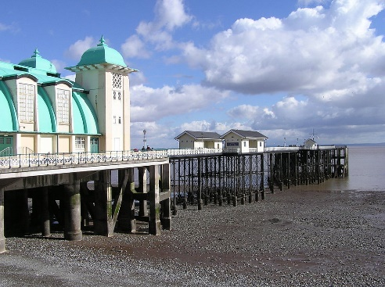  Pupils will use their research about our local beaches and the living creatures that have habitats there. They will find out information about how and why beaches are being protected and understand more about conservation and the environmental issues facing these creatures.  They will take part in an educational visit to a local beach to use the knowledge and skills they have gained over the topic to produce a final poster or presentation focussed on keeping our beaches healthy.  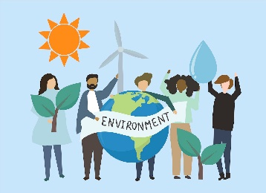  Growth Mindset  This year we will be exploring and learning all about Growth Mindset and how this impacts on our day to day tasks and activities in Year 2. Pupils will learn how to become more resilient in their learning and how they can develop a growth mindset when tackling challenges throughout the year. | Mathematical Development  In Numeracy we will be concentrating on:  - Number consolidation including addition, subtraction, multiplication and division.  - Learning the 2, 5, and 10 times tables  - Using measurement in our topic work  Number skills:  - Fractions.  - Revision of addition and subtraction methods.  - Money  - Temperature  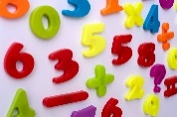  Measuring skills:  - Venn Diagrams and Carroll Diagrams.  - Reinforcing knowledge of 2D and 3D shapes.  - Using bar graphs and pictograms.  - Measurement of Length  - Measurement of weight.  - Direction and movement.  - Multiplication and division revision.  - Movement, Direction and Turns  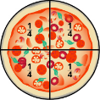  Consolidation of skills:  - Correct number formation,  - Counting in multiples of 10, 5 and 2.  - Doubling 1 digit numbers.  - Find one more / one less than a given number.  - Recognition of 2 digit numbers.  Romodels  The Children will research the Welsh Illustrator Emily Jones. We will talk about enthusiasm, perseverance and growth mindset. The children will explore artistic skills and audiences.
Health and Wellbeing  PE  Children are to wear PE kit to school on designated days.  Outdoor – Thursday Indoor – Tuesday  Thursday  Health, fitness and well-being, pupils will be given opportunities to engage in frequent and regular physical activity beneficial to their health, fitness and well-being.  Our topic this half term is Hockey and other Ball skills. We will be developing, consolidating and applying skills and techniques. The children will be given the opportunity to improve the efficiency and effectiveness of their skills (attack and defence) and specific techniques. They will continue to develop their cooperation with others and observe the  conventions of fair play, equality and  appropriate conduct in team activities.  Gymnastics (Tuesday)  The children will use the range of body schooling actions to create sequences which will then be shared and assessed by their peers. | Magic Moments  - Theme Week  - Illustrators  - Beach Visit  - RNLI Visit  - World Book Day  - St David’s Day/Eisteddfod  - Library Visit  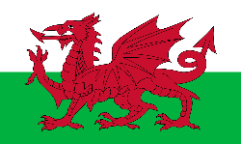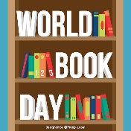  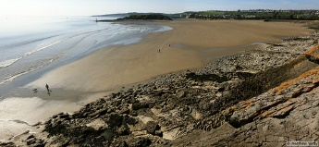  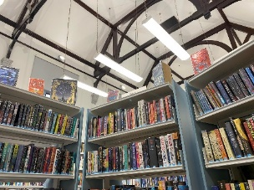 | Cynefin  “Cynefin” is a Welsh term defined by Curriculum for Wales as 'the place where we feel we belong, where the people and landscape around us are familiar, and the sights and sounds are reassuringly recognisable.’  - Sidoli Ice Cream  - Local Pier Visit  - Local Beach Trip  - Local Library Visit  - RNLI Visit
Children’s Independent Ideas

- How do you find sea glass?
- Where are the puffins?
- What is the best place to look for dolphins?
- Exploring fossils.
- Learning about the tide and moon.
- How does water get to the sea?
- Beach Safety
- RNLI visit
- Exploring the wildlife, fish and different species in rock pools and the ocean.

Humanities  - Learning about keeping beaches clean and tidy – Philosophy for Children  - Beached Whales and harm to animals and sea creatures.  - Creating coastline maps and keys  - Learning facts about sand, rocks, shells and crustaceans  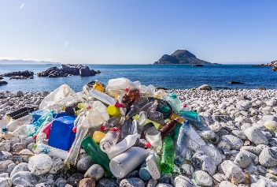  Geography  - Local trips and visits will be covered in this term, especially when visiting the beach and coastline.  - Staying Safe at the Seaside – linking with RNLI work  - Conservation and habitats  RVE  - Easter Story  - Shrove Tuesday  - Chinese New Year  - St David’s Day  - Ramadan and Eid  - Holi Festival of Colours | Expressive Arts  Art, Craft and Design:  - Describe similarities and differences between artwork on a common theme.  - Reflecting and responding to artwork.  - Researching and creating patterns found at the beach.  - Paintings of the sea.  - Easter Cards  Music  - Singing in a round.  - Create musical ideas and contribute to simple compositions.  - Learning music through our Beach combers topic. Eg. Classical-Handel’s Water music OR Pop-The Beach Boys  - Listening Diaries – exploring thoughts and feelings about music through sketching and writing responses to musical pieces.  Creative Movement  - Exploring movements related to the sea.  - Moving safely and confidently in general space, exploring changing speed level and direction.  - Learn a group dance using pattern, level, direction and space. | Science & Technology  Science Investigation  In Science we will be:  - Investigating rock pool habitats.  - Thinking about conservation and keeping our beaches healthy and safe.  - Researching rock pool creatures.  - Creature life cycles  - Erosion and degrading materials.  DT  - Designing a home for a hermit crab.  - Designing a rock pool creature.  - Beach Hut Design  ICT  In ICT we will be:  - Learning about online safety with Smartie the Penguin, Think U Know and Hector’s World.  - Working together to create a video using green screening.  - Creating a stop motion video.  - Exploring coding through HWB.  - Accessing work in Google Classroom  - Logging on and navigating through Hwb  - Using different websites such as SeeSaw, Giglets, Teach Your Monster, Lexia Core 5 and a variety of iPad apps.  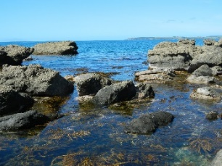
Health & Well-being  Physical Development  As part of Physical Development we will be looking at:  - Creating team games that can be enjoyed by other children in our class.  - Moving safely with control and co-ordination.  - Knowledge about spatial awareness and relationships such as below, underneath, over and on top of.  - Linking basic actions in a sequence, gradually improving their control and use of different shapes, levels and different directions of travel.  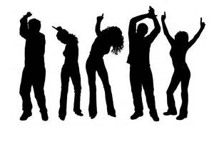  We will also be looking at:  - Developing fine motor skills – focus on pencil grip and cutting skills.  - Using and handling a growing range of tools.  - Cosmic Kids Yoga  - Get Kids Moving Superhero Workouts  Jigsaw  We will be using an online resource called Jigsaw to support our teaching of Personal, Social and Health education. The resource has an excellent track record in promoting wellbeing among pupils as well as helping them to deal with situations that they encounter in school and at home.  There are six units of work per year which all year groups will do at the same time.  This term the themes are:  - Dreams and Goals  - Healthy Me  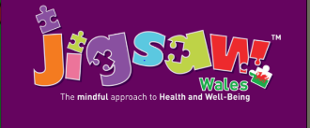 | Final Outcome:  Pupils will have used their research to explore a variety of creatures that live by the beach.  The children will have used this information to create Stop Motion videos of the life cycles of these creatures in their habitats.  The children will take part in an educational visit to a local beach to use the knowledge and skills they have gained over the topic to produce a final poster or presentation focused on keeping our beaches healthy and clean.  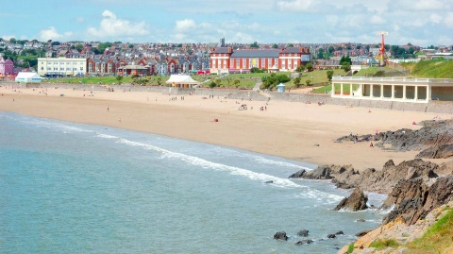  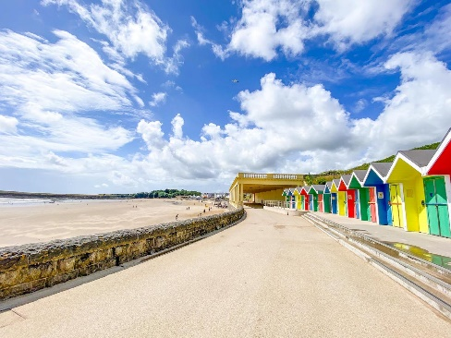
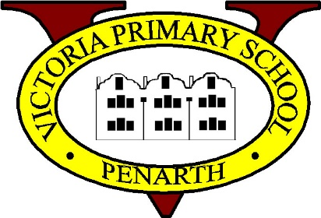
How can I support my child’s learning in this topic?
Useful websites to explore together:
Science
National Geographic Science

Science Kidz

General
https://hwb.wales.gov.uk/
(Child password required for access to school pages and outlook software, don’t forget that children can access Office online and J2E software to complete homework tasks. Digital homework can also be uploaded to Hwb)
http://resources.woodlands-junior.kent.sch.uk/interactive/text.htm#1
www.bbc.co.uk/skillswise
www.bbc.co.uk/schools/bitesize
http://www.topmarks.co.uk/Interactive.aspx?cat=75

Literacy:
Read regularly. Practise your weekly spellings. Ask questions about the texts you are reading so you improve their understanding.

Numeracy: Encourage your child to practice and learn by their 2, 5 and 10 times tables. Play number games that test your child’s times table knowledge. Play shopping games that encourage children to add and take away amounts of money.

