
Victoria Curriculum Summary

September 2022

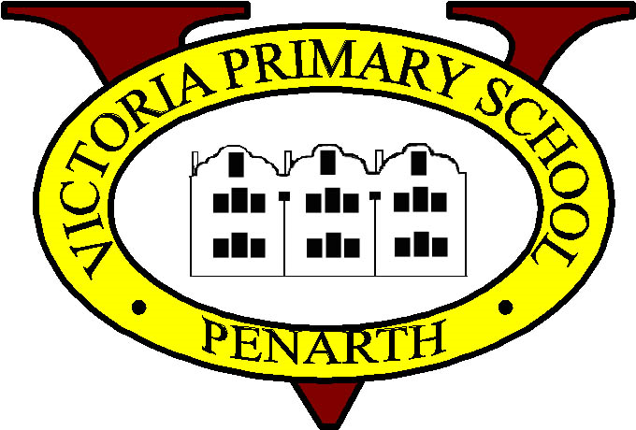

You can insert your ol logo here.

Curriculum for Wales
It’s an exciting time for learning in Wales.

In September, all primary schools and some secondary schools will be introducing the new Curriculum for Wales.
The curriculum, designed by teachers in your school, will support your child with creative lessons with a focus on positive experiences,
knowledge and skills. It will suit their needs and help them reach their full potential.

Curriculum Information
At Victoria Primary School, we are embracing the new curriculum for Wales and the exciting opportunities it allows.
Our Curriculum Vision was created by the children of the Curriculum Task Group. It summarises what they believe their curriculum should be and the experiences it should provide.

'Our vision is to provide a curriculum that is supportive, fun and challenging. It will help us to be resilient, responsible and creative. It will encourage everyone to be happy, healthy and prepared for their future.' Curriculum Task Group 2021.

The Victoria Curriculum has been developed as a result of parent, staff, pupil and governor feedback; identifying skills, knowledge and experience that the curriculum should include. The children and staff also completed a MAID (maintain, amend, include and discard) form to identify aspects of our current curriculum, that should be kept, added or changed as part of the new curriculum.
Central to, and underpinning, everything that we do are the four purposes. The four purposes are the starting point and aspiration for Victoria's Curriculum. Ultimately, the aim of a school's curriculum is to support its learners to become:

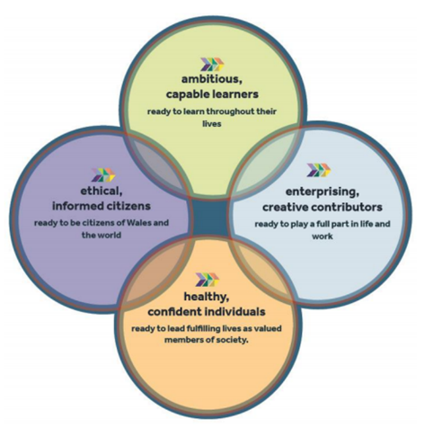
Our children will learn:
▪ Literacy skills – listening, speaking, reading and writing in Welsh and in English.
▪ Numeracy skills –using numbers in everyday life.
▪ Digital skills.
Learning will be done through the 6 areas of learning and experience as part of a chosen theme. The 6 areas are:
1. Expressive arts Art, Dance, Film, Drama, Music and Digital Media
2. Health and well-being learning about having a healthy body, and a healthy mind. Understanding healthy relationships and how to make good life decisions.
3. Humanities - finding out about history, geography, and religions. And also business and politics - how the country is run. And society - how people in our country live together.

4. Languages, literacy and communication - Learning and understanding different languages. Creating your own stories, poems or films. Our children will learn to use and understand British sign Language.
5. Maths and numeracy - Understanding and using numbers. Understanding and using symbols. Learning about shapes and measurement. How to collect and use information to make decisions.
6. Science and technology - Understanding nature and living things. Learning about designing and building things. And how technology works and how to use it to solve problems.

Children will also learn about:
▪ Human rights.
▪ Respecting people’s differences, like their beliefs or where they come from.
▪ Learning about work and how to choose the kind of work you want to do.
▪ Learning about Wales, your local area and the world.
▪ Relationships and sexuality, learning about things like feelings, healthy relationships and how we think about ourselves.

Assessment and Progression

Descriptions of learning provide guidance on how learners should progress within each Area of Learning and Experience as they journey through the continuum of learning. These are arranged in five progression steps which provide reference points for the pace of that progression. While the learning continuum is the same for each learner, the pace of progress through it may differ. As a result, the progression steps only broadly relate to age. They broadly correspond to expectations at ages 5, 8, 11, 14 and 16. Assessment should focus on identifying each individual learner’s strengths, achievements, areas for improvement and, where relevant, barriers to learning. This information should be used by the teacher, in discussion with the learner, to ascertain the next steps required to move learning forward, including any additional challenge and support required. This will be achieved by embedding assessment into day-to-day practice in a way that engages the learner.

This is only the start of our exciting curriculum journey and we will continue to monitor and evaluate its effectiveness on a termly basis, with the help of learners, staff, parents and governors. An updated termly summary newsletter, and information meeting for parents. Will highlight progress made and any adaptations required.

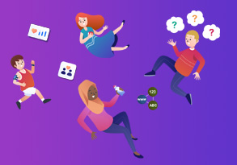

Curriculum for Wales

For more information, please visit

https://gov.wales/education-changing

Here you can access a guide for parents/carers


https://hwb.gov.wales/curriculum-for-wales/a-new-curriculum-in-wales-a-guide-for-parents/

And an easy read


https://hwb.gov.wales/curriculum-for-wales/a-new-curriculum-in-wales-easy-read/

You can also view an animation which explains the changes

https://www.youtube.com/watch?v=SCMLnc8lMxE&t=0s

BSL: information for children and young people about Curriculum for Wales and BSL in the curriculum

BSL and the Curriculum for Wales (BSL/English)

(18) BSL a Cwricwlwm i Gymru // BSL and the Curriculum for Wales (BSL only)

Additional Learning Needs
Additional learning needs (ALN) system: parents’ guide

